German Companies in Georgia

Mercedes-Benz USA, LLC
Headquartered in Atlanta, MBUSA is responsible for the distribution, marketing and customer service for all Mercedes-Benz products in the United States. MBUSA offers drivers the most diverse lineup in the luxury segment with model lines ranging from the sporty CLA-Class four-door coupe to the flagship S-Class. MBUSA is also responsible for Mercedes-Benz Vans and smart products in the U.S. www.mercedes-benz.com

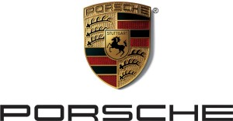Porsche Cars North America, Inc.
Porsche Cars North America, Inc. (PCNA), based in Atlanta, Ga. is the exclusive U.S. importer of Porsche sports cars, the Cayenne SUV and Panamera sports sedan. They work to provide Porsche customers with a best-in-class experience that is in keeping with the brand’s 63-year history and leadership in the advancement of vehicle performance, safety and efficiency. www.porsche.com

SAPPHIRE LEVEL PATRONS
BESTAR LLC
Since 1978 BESTAR has been an ISO 9001 certified specialty steel supplier servicing companies that manufacture various cutting tools such as saws and knives for industrial applications. BESTAR regularly supplies customers in over 45 countries in the world, and is headquartered in Remscheid, Germany with additional offices and warehouses in Atlanta, GA, USA, as well as Shanghai and Hong Kong, China. BESTAR is proud to be known throughout the cutting tool industry as not only the go-to vendor for material availability, but also for the highest quality products available on the market today. www.bestar-steel.com
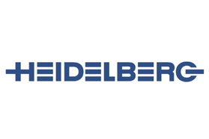Heidelberg USA, Inc.
Heidelberger Druckmaschinen Aktiengesellschaft (Heidelberg) has been a major provider and partner for the global printing industry for many years. They offer their customers all necessary components essential to the success of their business activities in commercial and packaging printing. www.heidelberg.com

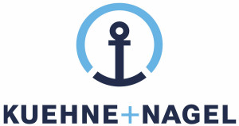Kuehne + Nagel, Inc.
With more than 120 forwarding offices and distribution centers, the staff of 6,000 logistics professionals at Kuehne + Nagel leverages their expertise to deliver consistent, optimized service to our clients. Over a 120 year history, Kuehne + Nagel has evolved from a traditional international freight forwarder to a leading global provider of innovative and fully integrated supply chain solutions. www.kn-portal.com

Rödl Langford de Kock LLP
Rödl & Partner USA have specifically tailored their accounting, auditing, tax and business consulting services to the unique needs of foreign owned business in the United States of America. For the past 40 years their core practice has been serving the accounting and tax needs of German speaking and other foreign owned “Mittelstand” companies operating in the U.S. www.roedl.com/us

Schuh Complexity Management Inc.
Schuh Complexity Management Inc. focuses on providing solutions and methods for managing the ever increasing complexity of today‘s enterprises, products and processes. With this approach, the company was established as an implementation-oriented problem solver in the industry. Today the company consists of about 50 people committed to ensure your company’s success through their work as strategy and organizational consultants, as well as management coaches. Headquartered in Aachen, Germany, with subsidiaries in St. Gallen, Switzerland (since 1991), and Atlanta, GA, USA (since 1997). www.schuh-group.com

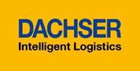DACHSER SE
The company, headquartered in Kempten, was established in 1930 and is one of the global leaders in the field of system logistics today. A seamless global transport network and exemplary IT solutions guarantee the most intelligent combination and integration of logistics network competences worldwide. www.dachser.com

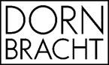DORNBRACHT AMERICAS INC.
Dornbracht represents the very highest quality of manufacturing, progressive production and innovative design. The premium fittings of this family-run company have won numerous international awards, acting as a driving force for the developments and trends of an entire industry. Worldwide. www.dornbracht.com

I.K. Hofmann USA, Inc.
Hofmann Services is a leading international provider of professional employment services. We have over 20,000 employees working in over 100 locations across five countries in fields ranging from industrial to office, marketing to engineering, technology and more. www.hofmann-services.com

Der Biergarten
Der Biergarten gives Atlanta residents and visitors a true taste of German culture. Located Downtown within the Luckie Marietta District, Der Biergarten fills a citywide void of beer gardens and authentic German fare while providing world-class service in a festive, traditional atmosphere. www.derbiergarten.com

GACC South
The German American Chamber of Commerce of the Southern United States, Inc. (GACC South) was founded in 1978 to promote and support bilateral trade between Germany and the U.S. The GACC South is headquartered in Atlanta, Georgia, with a branch office in Houston, Texas. The GACC South is a private, non-profit organization and serves as the official representative of German industry and trade in the Southern U.S. It is part of an international network composed of 130 German foreign chambers of commerce and government offices in 90 countries. www.gaccsouth.com

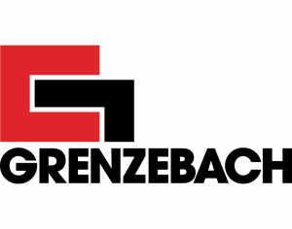Grenzebach
Grenzebach is an internationally operating, expanding family-owned company focusing on plant engineering, construction and automation. Grenzebach provides customized equipment based on cutting-edge technologies designed to perform highly sophisticated processing and automation tasks. www.grenzebach.com

